Steps to add the Supporting INPAG badge to your LinkedIn Profile

Step 1: Log into your LinkedIn Account.
Step 2: Open a new tab and go to the “Support us” page on the IFR4NPO website.
Step 3: Click on the “Add to profile” button under the INPAG Badge. This will take you to the Add license or certification tab on your LinkedIn profile.
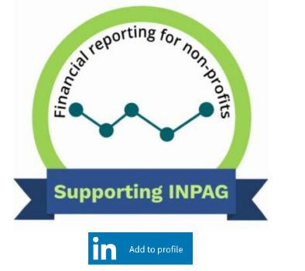
Step 4: Click the “Save” button to add the certification to your profile.
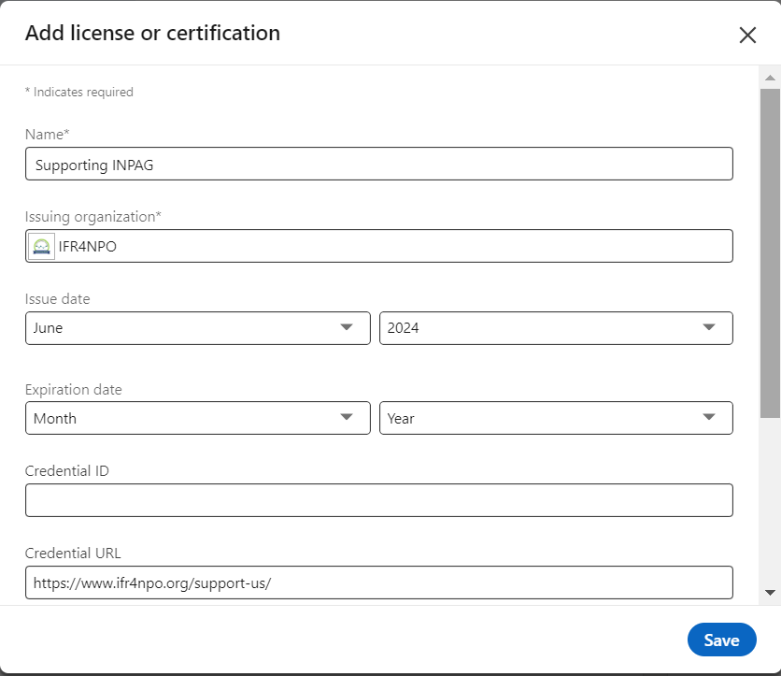

Step 5: To share, click next, which generates a default message and image.

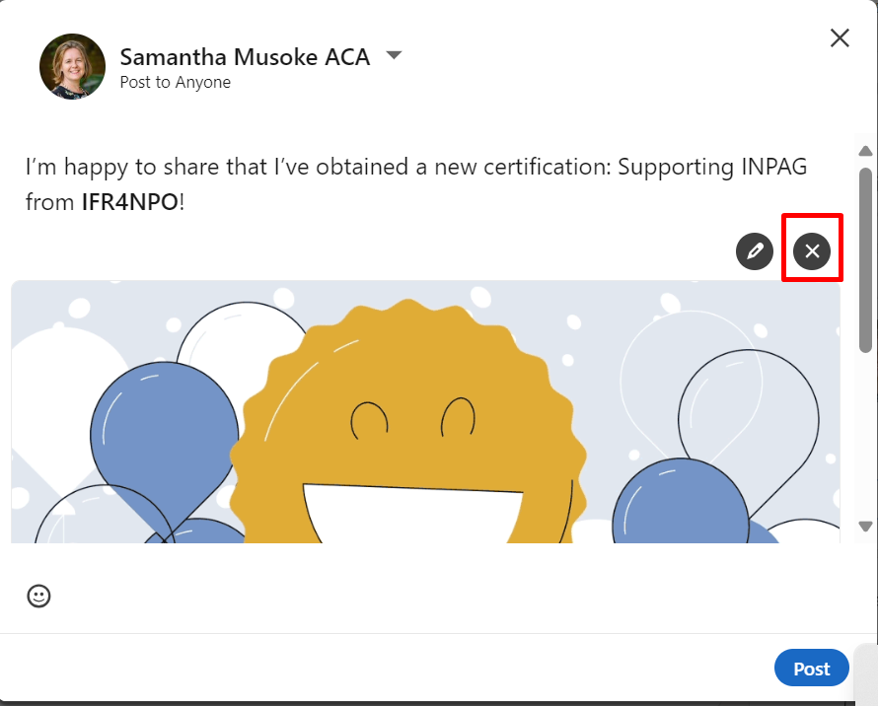

Step 6: Click on the black ‘X” to delete the default image
Step 7: Download this image of the badge. Then click the ‘add photo’ icon and select the badge image.
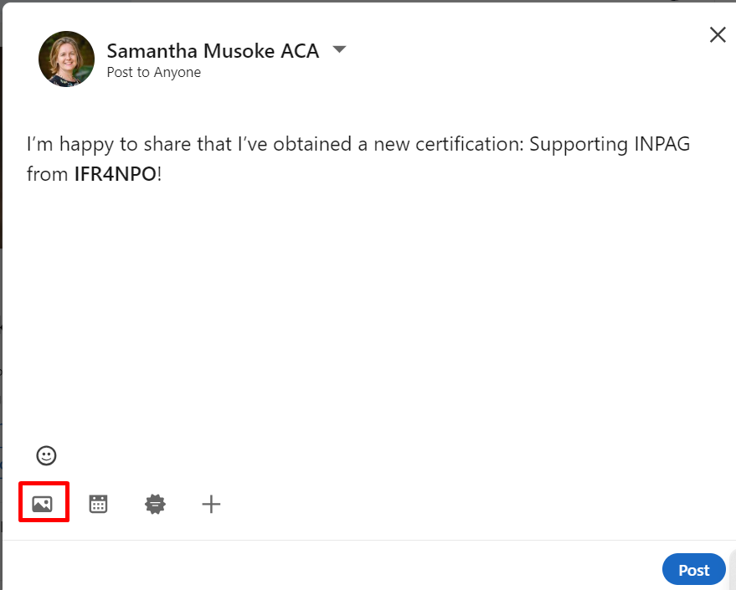
Step 8: Craft your message, and post.
Use your own words – or check out some of the ideas below for inspiration! Remember to tag us by typing @IFR4NPO somewhere in your post.
‘I am proud to support INPAG – improving transparency, building trust’
‘Join me in supporting ‘International Non-Profit Accounting Guidance’ (INPAG), it will transform the sector!’
‘I am delighted to be a supporter of INPAG (International Non-Profit Accounting Guidance) and advocate for efficiency, equity and accountability in non-profit financial reporting.’
You might also like to use any of these key phrases that relate specifically to Exposure Draft 3

- Fund accounting provides essential information about the source and use of funds.
- The proposals enable accountability without external control – which is at the heart of shifting power and trust-based philanthropy
- Transparency about support costs opens the way to full cost recovery
- A standard grant report will reduce the burden of multiple formats

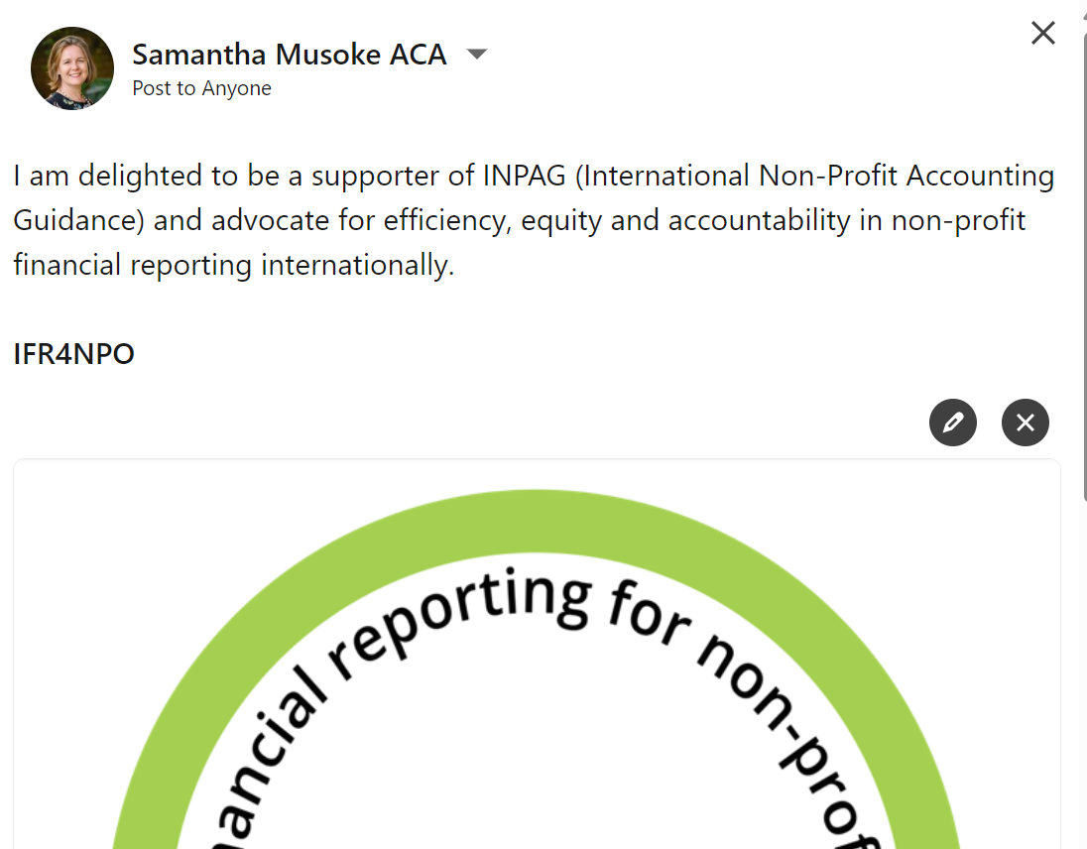

Thank you :-)

If you encounter any issues during the process, please send a message directly to us via LinkedIn (this button is at the top right corner of your screen when you visit the IFR4NPO LinkedIn page) or email for additional assistance.

